ENVIRONMENT SETUP

IBM CLOUD ACCOUNT CREATION

|  |  |
| --- | --- |
| Team ID | PNT2022TMID18761 |
| Project Name | News Tracker Application |

VENKATA SAI SUMANTH KOVURU

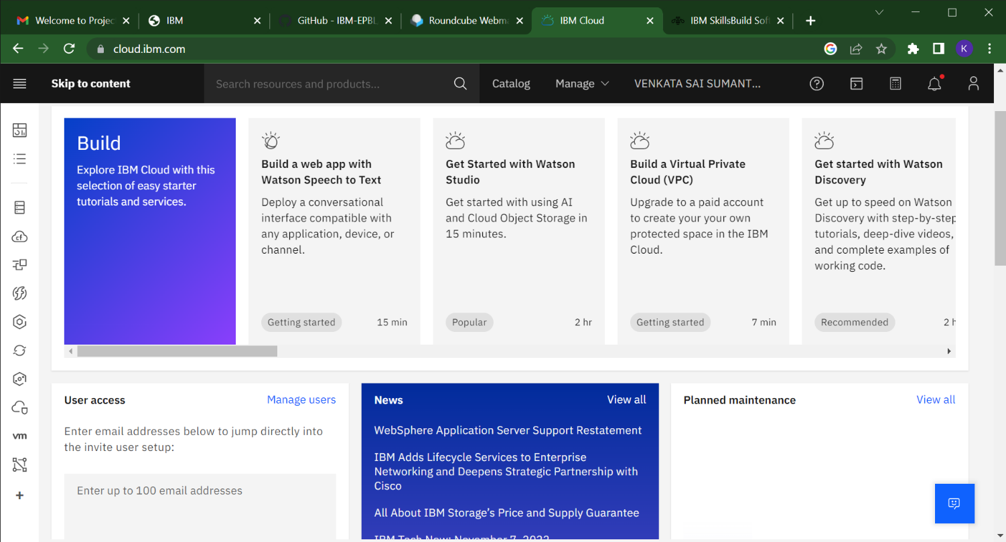

P

PRASANTH KUMAR TELLA

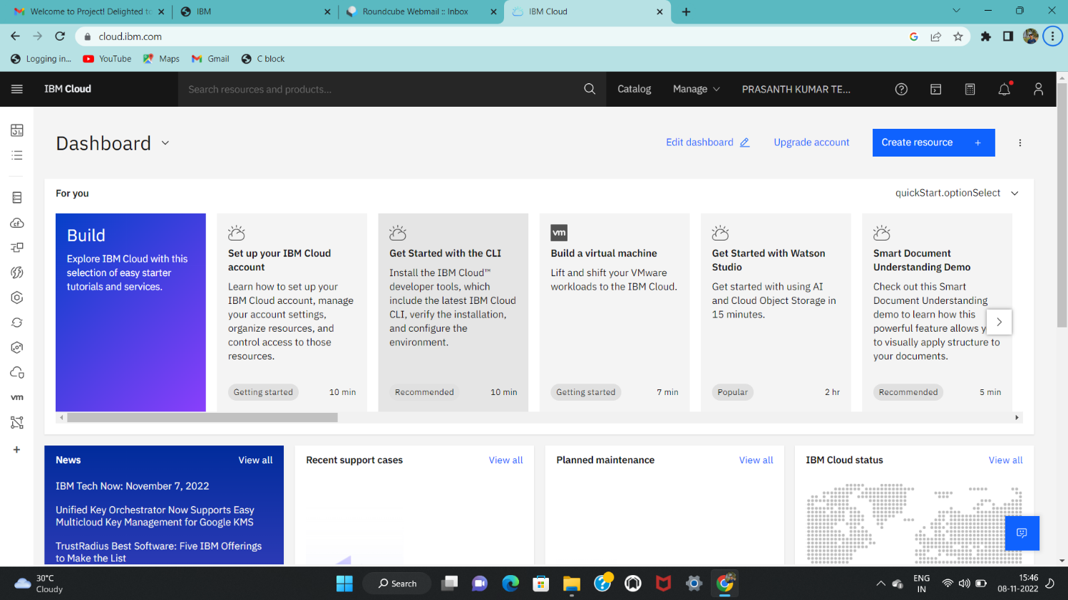

LOKESH RACHURI

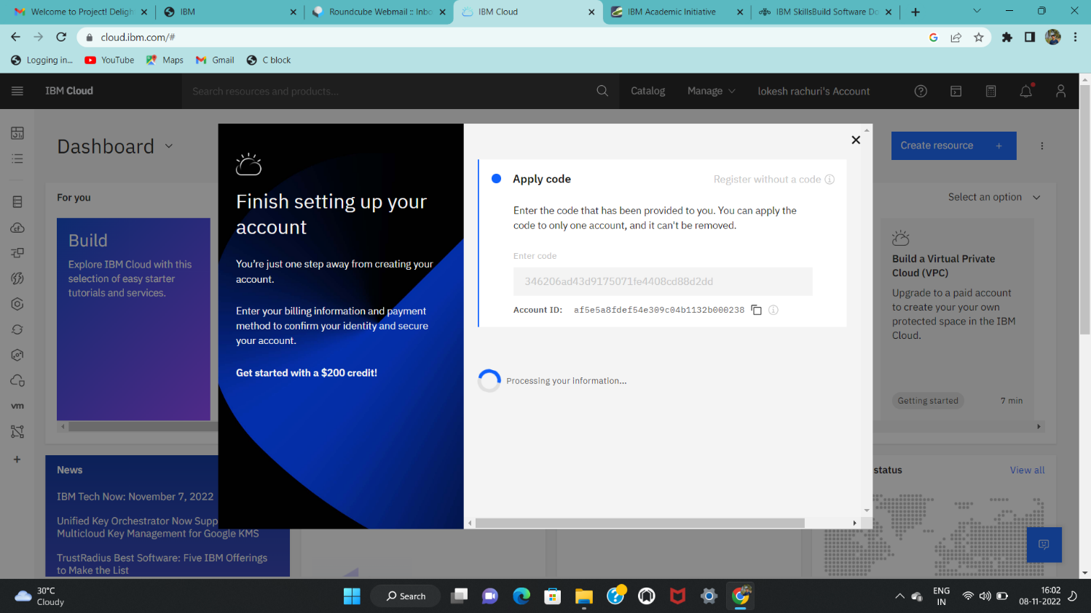

KISHORE THALLISETTY

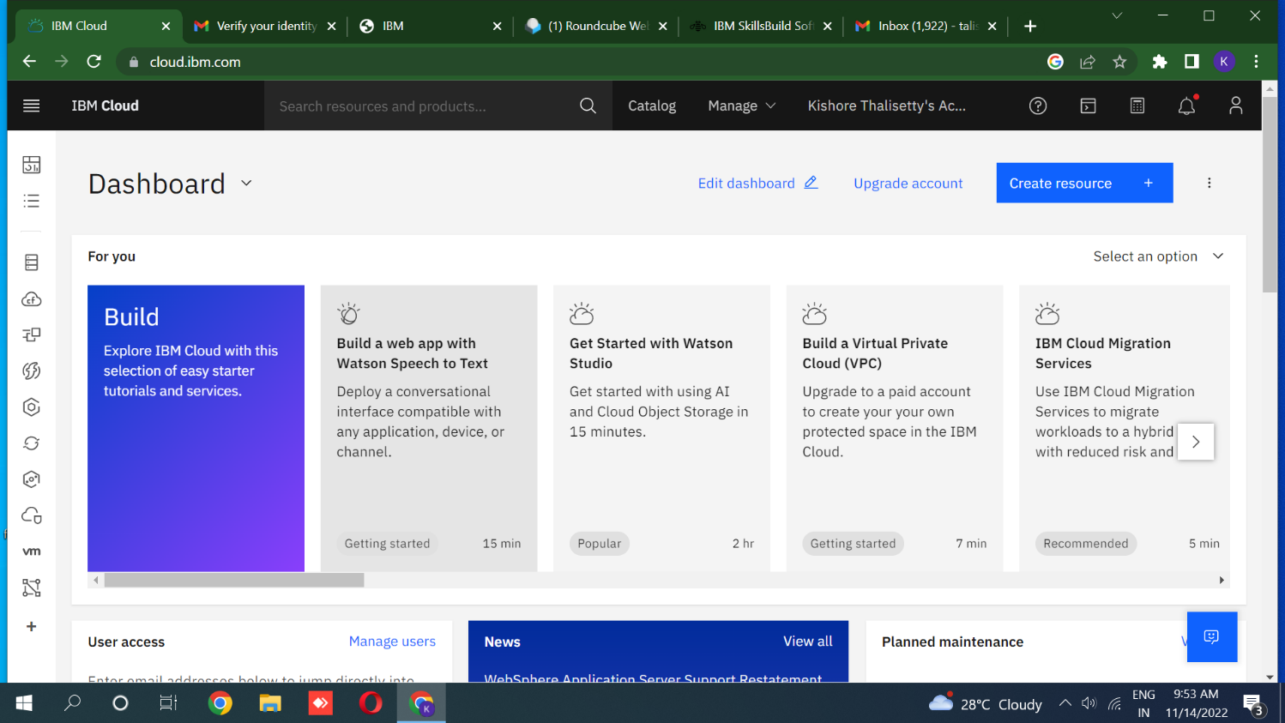

Anushiya R

